|  |  |
| --- | --- |
|  |  |

**PLASTIC (P.E.T) FULL FACE SHIELDS**

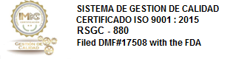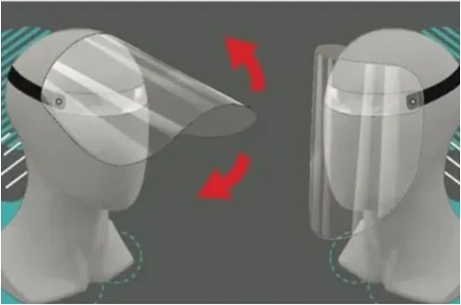

**Introduction**

In response to changing market demands of public protection against the present pandemic, we have partnered in Mexico with BP Commodities SA de CV to bring our solution to market on personal protection. Our PVC face masks are designed for:

* Restaurant employees
* Grocery store employees
* Any public service employees
* General public safety

**Product Specifications**

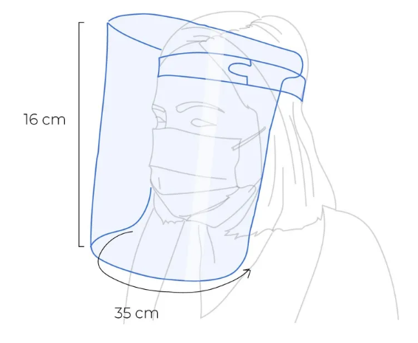

Designed to protect face, eyes and neck, 90-degree flexibility capacity, PVC or PET viewer. Useful for jobs that require protection across the face. Transparent and thermoformable, multi-formable PVC-PET vinyl polychloride. It is produced under strict quality standards.

**Features:**

* Each face mask comes in individual bag
* Elastic Headband
* 100% recyclable.
* Odorless Material.
* Non-toxic.
* Lightweight, comfortable, reusable.
* Its design and ergonomics allow the use of glasses

**Storage Conditions:**

* It is recommended to store the material in its original packaging, at a temperature of 15 to 25 C, outside the range of sunlight and severe humidity conditions.
* The material should not be hit for any reason.
* The facemask should be considered as fragile in the handling prior to its processing.
* To disinfect can be washed with soap, chlorine or alcohol, dry immediately without sun exposure

|  |  |  |
| --- | --- | --- |
| **Test Data** | | |
| **Characteristics** | **Values** | **Test Method** |
| PVC Thickness, (Gauge) | 20 Caliber | ASTM D-374 |
| Weight (g/cc) | 1.39/0.02 | ASTM D-792 |
| Bright (Gardner) | 115 min | ASTM D-2457 |

|  |  |  |  |
| --- | --- | --- | --- |
| **Weight**  90 grams | **Height**  16 cm | **Width**  35 cm | **Length**  30 cm |

**Production Data**

Manufacturing Capacity: **2,100,000** units per week

Inventory as of 05/08/2020: **310,000** units

Lead Time: 4 Days

Production Location: Mexico City

**Shipping Data**

|  |  |
| --- | --- |
| Master Case: 60 units |  |
| Pallet: 40 master cases / 2,400 units.  Pallet Weight: 600 KG | |

**Price**

* Price: **$1.99** per unit Ex-Factory, **Mexico City, Mexico**
* Minimum order: One (1) truckload / 26 pallets / 62,400 units
* Subject to change and prior sale.

**Product Variations**

We do our best to offer you the most price accessible Full-Face Masks in the Industry. Sometimes companies wish to have a variation on products, and we do the best to accommodate our clients.

2 Main Variations which we are frequently asked about:

|  |  |
| --- | --- |
| **Added Corporate Logo** | **Foam Head Band** |

Note: If you have any product adjustments you feel are required, please let us know so we can offer you the best solutions.